LISTENING PRACTICE

COMPLETE WITH THESE OPTIONS:
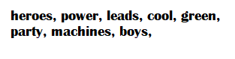TEENS, TEAM, ATTACKS
https://www.youtube.com/watch?v=AxuvUAjHYWQ

